ST.XAVIER’S COLLEGE

(Affiliated to Tribhuvan University)

Maitighar, Kathmandu



**DBMS LAB ASSIGNMENT #2**

**SUBMITTED BY:**

Tisa Maharjan

017BSCIT046

4th Sem, 2nd Year

**SUBMITTED TO:**

Mr. Sarjan Shrestha

Lecturer, Dept. of Computer Science

St. Xavier’s College

Maitighar, Kathmandu

**Objective**

**To learn about Data Manipulation Language (DML)**

**Tasks**

**Lab Task (Reference tables that are created using SQL script that I shared earlier in classroom)**

1. Write a query to display the names (firstName, lastName) using alias name “First Name", "Last Name”.(employees table)

select firstName as "First Name",lastName as "Last Name" from employees;

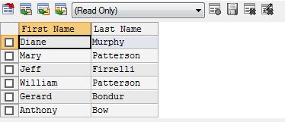

1. Write a query to display full name of employee using alias name “Full Name”. (employees table)

select concat(firstName,' ',lastName) as "Full Name" from employees;

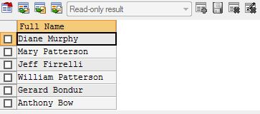

1. Write a query to get all employee details from the employee table order by first name, descending.

select * from employees order by firstName desc;

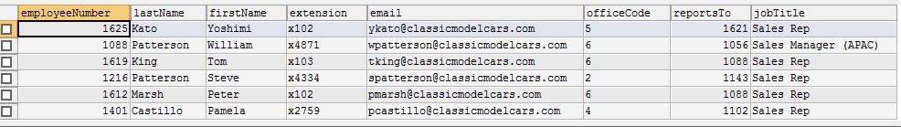

1. Write a query to get the number of employees working with the company. (employees table)

select count(*) from employees;

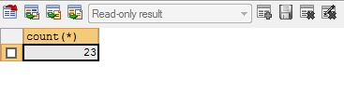

1. Write a query to get the job titles in the employees table. (employees table)

select jobTitle from employees group by jobTitle;

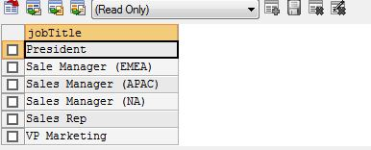

1. From ‘products’ table find the details (productName , productLine, productDescription, quantityInStock) of the product with maximum stock quantity.

select max(quantityInStock)as "Quantity in Stock",productName,productLine,productDescription,quantityInStock from products;



1. Find the customer details ( “Name of Customer”, “Contact Person”(contactFirstName + contactLastName),  city and country) for the customers from cities (Nantes,Las Vegas,Madrid).(from customers table)

select customerName as "Name of Customer",concat(contactFirstName,' ',contactLastName) as "Contact Person",city,country from customers where city in ("Nantes","Las Vegas","Madrid");

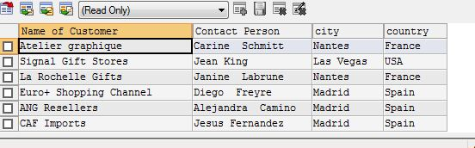

1. Write a query to retrieve the unique values of productLine from “products” table (from product table).

select productLine from products group by productLine;

or

select distinct productLine from products;

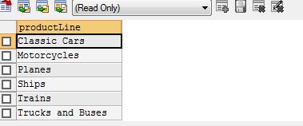

1. Find the total number of quantityInStock for productLine ‘Motorcycles’ (from product table).

select productLine as "Product",count(quantityInStock) from products where productLine="Motorcycles";

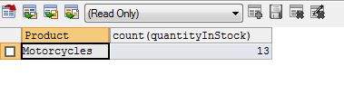

1. From orders table , find out the orderNumber, orderDate and customerNumber for orders that are ‘In Process’(i.e. status =’In Process’).

select orderNumber,orderDate,customerNumber from orders where status="In Process";

